Marcus J. Anderson

**Step 2 - *Explore the data by answering the following questions:***

**Dataset:** deaths-in-custody

**Number of Observations:** 8,373

**Number of Variables:** 17

**Regulated Domain in Law:** None

**Number of Protected Class Variables:** 3

|  |  |  |
| --- | --- | --- |
|  | **Protected Class** | **Law** |
| **race** | Race | Civil Rights Act of 1964, 1991 |
| **age** | Age | Age Discrimination in Employment Act of 1967 |
| **gender** | Sex | Equal Pay Act of 1963; Civil Rights Act of 1964, 1991) |

**Step 3 *-******Determine the relationships between dependent and independent variables:***

|  |  |  |
| --- | --- | --- |
| **Independent Variable - Race** | **Dependent Variable – Manner of Death** | **Dependent Variable – Custody Status** |
| Race - American Indian | Accidental: 6  Homicide: 9  Natural: 50  Other: 3  Suicide: 12 | Booked - Awaiting Trial: 6  Booked - No Charges Filed: 2  Other: 10  Sentenced: 62 |
| Race - Asian Indian | Cannot be Determined: 1  Homicide: 2  Natural: 8  Other: 1  Suicide: 6 | Booked - Awaiting Trial: 9  Booked - No Charges Filed: 1  Other: 3  Sentenced: 5 |
| Race - Black | Accidental: 142  Cannot be Determined: 29  Homicide: 294  Natural: 1348  Other: 65  Suicide: 94 | Awaiting Booking: 20  Booked - Awaiting Trial: 211  Booked - No Charges Filed: 43  Other: 382  Sentenced: 1316 |
| Race - Cambodian | Accidental: 1  Homicide: 2  Natural: 1  Other: 1 | Booked - Awaiting Trial: 1  Other: 3  Sentenced: 1 |
| Race - Chinese | Accidental: 2  Homicide: 3  Natural: 4  Other: 1  Suicide: 5 | Booked - Awaiting Trial: 6  Other: 3  Sentenced: 6 |
| Race - Filipino | Accidental: 1  Cannot be Determined: 1  Homicide: 6  Natural: 37  Other: 5  Suicide: 5 | Booked - Awaiting Trial: 6  Booked - No Charges Filed: 1  Other: 12  Sentenced: 36 |
| Race - Guamanian | Accidental: 1  Natural: 2 | Sentenced: 3 |
| Race - Hawaiian | Cannot be Determined: 1 | Booked - Awaiting Trial: 1 |
| Race - Hispanic | Accidental: 247  Cannot be Determined: 26  Homicide: 646  Natural: 1211  Other: 101  Suicide: 263 | Awaiting Booking: 31  Booked - Awaiting Trial: 286  Booked - No Charges Filed: 54  Other: 758  Sentenced: 1365 |
| Race - Japanese | Cannot be Determined: 1  Other: 1  Suicide: 2 | Booked - Awaiting Trial: 1  Other: 1  Sentenced: 2 |
| Race - Korean | Homicide: 7  Natural: 7  Suicide: 2 | Booked - Awaiting Trial: 1  Other: 6  Sentenced: 9 |
| Race - Laotian | Accidental: 1  Homicide: 2  Natural: 4  Suicide: 3 | Booked - Awaiting Trial: 2  Other: 2  Sentenced: 6 |
| Race - Other | Accidental: 7  Cannot be Determined: 2  Homicide: 19  Natural: 87  Other: 3  Suicide: 19 | Booked - Awaiting Trial: 9  Booked - No Charges Filed: 7  Other: 30  Sentenced: 91 |
| Race - Other Asian | Accidental: 6  Homicide: 20  Natural: 16  Other: 1  Suicide: 18 | Booked - Awaiting Trial: 13  Booked - No Charges Filed: 1  Other: 22  Sentenced: 25 |
| Race - Pacific Islander | Homicide: 11  Natural: 3  Other: 3  Suicide: 2 | Booked - Awaiting Trial: 1  Other: 15  Sentenced: 3 |
| Race - Samoan | Homicide: 5  Natural: 2  Suicide: 1 | Other: 5  Sentenced: 3 |
| Race - Vietnamese | Accidental: 4  Cannot be Determined: 2  Homicide: 11  Natural: 13  Suicide: 5 | Awaiting Booking: 1  Booked - Awaiting Trial: 7  Booked - No Charges Filed: 2  Other: 12  Sentenced: 13 |
| Race - White | Accidental: 265  Cannot be Determined: 52  Homicide: 468  Natural: 2142  Other: 94  Suicide: 419 | Awaiting Booking: 45  Booked - Awaiting Trial: 471  Booked - No Charges Filed: 92  Other: 583  Sentenced: 2249 |

**Race – Manner of Death Chart**

**Race – Custody Status Chart**

|  |  |  |
| --- | --- | --- |
| **Independent Variable - Gender** | **Dependent Variable – Manner of Death** | **Dependent Variable – Custody Status** |
| Gender - Female | Accidental: 55  Cannot be Determined: 9  Homicide: 52  Natural: 281  Other: 16  Suicide: 58 | Awaiting Booking: 15  Booked - Awaiting Trial: 106  Booked - No Charges Filed: 32  Other: 84  Sentenced: 234 |
| Gender - Male | Accidental: 628  Cannot be Determined: 106  Homicide: 1453  Natural: 4654  Other: 263  Suicide: 798 | Awaiting Booking: 82  Booked - Awaiting Trial: 925  Booked - No Charges Filed: 171  Other: 1763  Sentenced: 4961 |

**Gender – Manner of Death Chart**

**Gender – Custody Status Chart**

|  |  |  |
| --- | --- | --- |
| **Independent Variable - Age** | **Dependent Variable – Manner of Death** | **Dependent Variable – Custody Status** |
| Age – 40 and Under | Accidental: 365  Cannot be Determined: 61  Homicide: 1026  Natural: 485  Other: 149  Suicide: 506 | Awaiting Booking: 42  Booked - Awaiting Trial: 381  Booked - No Charges Filed: 83  Other: 1244  Sentenced: 842 |
| Age – Over 40 | Accidental: 318  Cannot be Determined: 54  Homicide: 478  Natural: 4450  Other: 130  Suicide: 350 | Awaiting Booking: 55  Booked - Awaiting Trial: 680  Booked - No Charges Filed: 120  Other: 602  Sentenced: 4353 |
| Age - Unknown | Homicide: 1 | Other: 1 |

**Age – Manner of Death Chart**

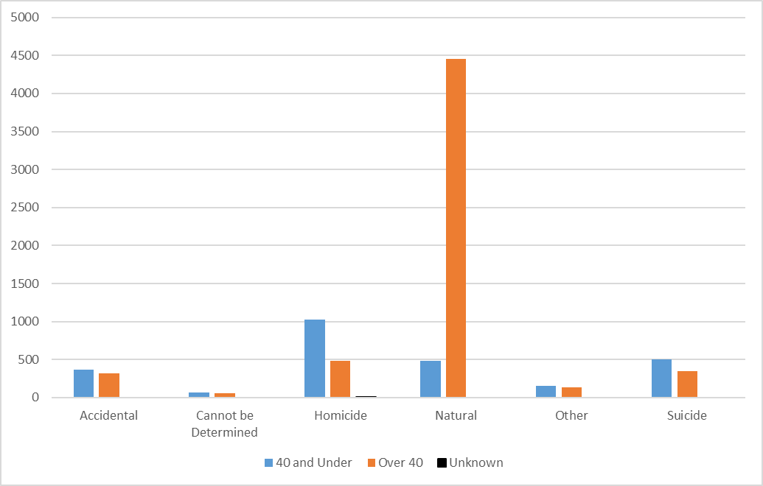

**Age – Custody Status Chart**

**Step 4 - *Show how to manipulate with data:***

**Fair Hypothesis**

**Bias Hypothesis**

**Step 5 – *Original vs. Reduced Data – Mean, Median, and Mode:***

|  |  |  |  |
| --- | --- | --- | --- |
| **Protected Class Variable (Gender)** | **Mean** | **Median** | **Mode** |
| Original Data Set | 0.05625 (NO) | 0 (NO) | 0 (NO) |
| Reduced Data Set | 0.05541 (YES) | 0 (NO) | 0 (NO) |
| Difference | Difference | No Difference | No Difference |

**Step 6 – *Original vs. Reduced Data - Graph Comparisons:***

**Original Graph (Gender – Manner of Death)**

**Reduced Graph (Gender – Manner of Death)**

**Explanation:**

The main difference between the reduced graph and the original is that the statistics for the ‘Male’ and ‘Female’ categories seem to be inverted. This may be due to the random sampling method only having two options to work off of as opposed to five or six, limiting randomness.

By using the random sampling method, we see that the ‘Female’ members would now benefit, and the ‘Male’ members would suffer. Since we’ve only worked off two options for the independent variable (gender), there wouldn’t be a case where all members of this protected class will benefit from random sampling.